
GETTING STARTED IN PCIE
Project Plan
Notes: This worksheet has been developed to help researchers
start to plan their PCIE activities. Read through the
PCIE - A How-to Guide and use this form to capture your initial ideas.
Please contact us on spft.publicinvolvementarckss@nhs.net if you need any support with developing your ideas.

- Basic Information
Name of researcher(s):

Research project:

Theme (if appropriate):

- Brief research summary (to help the PCIE team understand the context)
- Recruiting members of the public
Who do you want to hear from — a specific group of individuals or a broader audience? Do you (or your colleagues) already have contacts who can help you reach them?

- PCIE Budget
Where is your PCIE budget coming from (which organisation will make the payments), and how much funding is available?

- Communication and Accessibility
Have you written a plain language summary of your research aims? Have you asked public members how they’d like to be contacted (email, phone, WhatsApp, website updates)? How will you make meetings and events accessible — for example with suitable venues, online options, or clear materials?

- Equality, Diversion and Inclusion
How will you make sure people from marginalised groups are included?

- Planning for PCIE at different stages of the research cycle
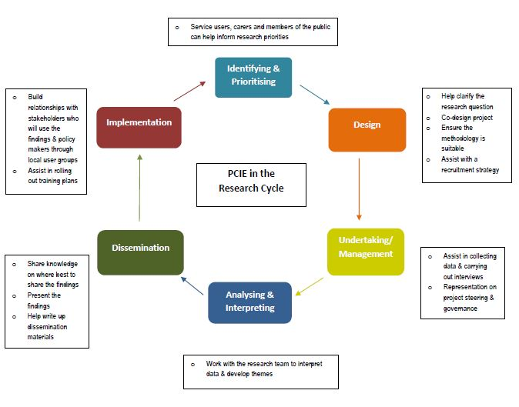

Looking at the diagram above (also in the PCIE Guide), where in your research could public involvement be used?

- Feedback, Impact and Evaluation
At what point in your research cycle will you collect and give feedback to public contributors (during engagement, involvement and participation)?
How will you monitor and evaluate public involvement and its impact throughout the project?
It helps to plan this from the start.

There are resources to support your plan development on our webpages.
Pippa & Lou
The PCIE team at ARC KSS
spft.publicinvolvementarckss@nhs.net

