
GETTING STARTED IN PCIE
WORKSHEET
Notes: This worksheet has been developed to help researchers
start to plan their PCIE activities. Read through the
PCIE - A How-to Guide, and use this form to capture your initial ideas
before contacting us on PublicInvolvementARCKSS@spft.nhs.uk

- Basic Information
Name of researcher(s):

Research project:

Theme (if appropriate):

- Brief research summary (to help the PCIE team understand the context)
- Recruiting members of the public
Who would you like to hear the views of? Is it a specific group of individuals or more general?
Do you have any existing contacts (yourself or through colleagues) who can help you to contact those people?

- PCIE Budget
Where is your PCIE budget coming from? How much do you have?

- Communication and Accessibility
Have you written a plain language summary of your research aims?
Have you considered how the public members you work with might like to be contacted? Email, phone, WhatsApp, website updates, Twitter?
How can you make your meetings/events accessible?

- Equality, Diversion and Inclusion
How can you ensure you include people from marginalised groups?

- Planning for PCIE at different stages of the research cycle
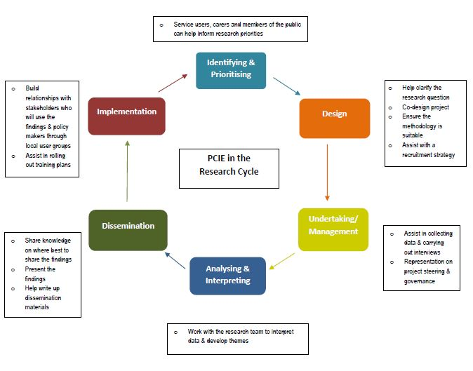

Take a look at the diagram, above, in the PCIE Guide. Where in your research do you think you could use public involvement?

- Feedback, Impact and Evaluation
Where in your research cycle will you collect/give feedback?
How you are going to monitor and evaluate public involvement and its impact throughout the project? Think about planning this from the start.

We look forward to reading through your answers to this form and thinking about how we can help you.
Pippa & Lou
The PCIE team at ARC KSS
PublicInvolvementARCKSS@spft.nhs.uk

